**Assignment -4**

WOWKI SIMULATION

|  |  |
| --- | --- |
| Assignment Date | 4th NOVEMBER 2022 |
| Student Name | Ariya Krishna.G |
| Student Roll Number | 960219106033 |
| Maximum Marks | 2 Marks |

**Question-1:**

Write a code and make a connection in WOKWI for ultrasonic sensor. Whenever distance is less than 100 , send “alert” to IBM cloud and display in device recent events.

**PROGRAM**

#include <WiFi.h>

#include <PubSubClient.h>

WiFiClient;

String data3;

#define ORG "b4hkg6"

#define DEVICE_TYPE "b11m3edevicetype" #define

DEVICE_ID "b1m3edeviceid"

#define TOKEN "Ao?yFfGVDA7dcv-KyQ"

#define speed 0.034 #define led 14 char server[] = ORG

".messaging.internetofthings.ibmcloud.com"; char publishTopic[] =

"iot-2/evt/Arya/fmt/json"; char topic[] = "iot-

2/cmd/led/fmt/String"; char authMethod[] = "use-token-auth"; char token[] = TOKEN;

charclientId[] = "d:" ORG ":" DEVICE_TYPE ":" DEVICE_ID;

PubSubClientclient(server, 1883, wifiClient);

constinttrigpin=5; const

intechopin=18;

String command;

String data="";

long duration; float dist;

void setup()

{

Serial.begin(115200); pinMode(led, OUTPUT); pinMode(trigpin, OUTPUT); pinMode(echopin, INPUT); wifiConnect(); mqttConnect();

}

void loop() { boolisNearby

= dist< 100;

digitalWrite(led, isNearby);

publishData();

delay(500);

if (!client.loop()) { mqttConnect();

}

}

voidwifiConnect() {

Serial.print("Connecting to "); Serial.print("Wifi");

WiFi.begin("Wokwi-GUEST", "", 6); while

(WiFi.status() != WL_CONNECTED) { delay(500);

Serial.print(".");

}

Serial.print("WiFi connected, IP address: "); Serial.println(WiFi.localIP());

}

voidmqttConnect() { if (!client.connected()) {

Serial.print("Reconnecting MQTT client to "); Serial.println(server); while (!client.connect(clientId, authMethod, token)) { Serial.print("."); delay(500);

}

initManagedDevice();

Serial.println();

}

}

voidinitManagedDevice() {

if (client.subscribe(topic)) {

//

Serial.println(client.subscribe

(topic));

Serial.println("IBM subscribe to cmd OK");

} else {

Serial.println("subscribe to cmd FAILED");

}

}

voidpublishData()

{

digitalWrite(trigpin,LOW);

digitalWrite(trigpin,HIGH); delayMicroseconds(10); digitalWrite(trigpin,LOW); duration=pulseIn(echopin,HIGH); dist=duration*speed/2; if(dist<100){ String payload = "{\"Alert Distance\":"; payload += dist; payload += "}";

Serial.print("\n");

Serial.print("Sending payload: "); Serial.println(payload); if (client.publish(publishTopic, (char*) payload.c_str())) {

Serial.println("Publish OK");

}

}

if(dist>100){

String payload = "{\"Distance\":"; payload += dist; payload += "}";

Serial.print("\n");

Serial.print("Sending payload: "); Serial.println(payload); if(client.publish(publishTopic, (char*) payload.c_str())) {

Serial.println("Publish OK");

}else {

Serial.println("Publish FAILED");

}

}

}

**OUTPUT:**

**WOKWI SIMULATION**

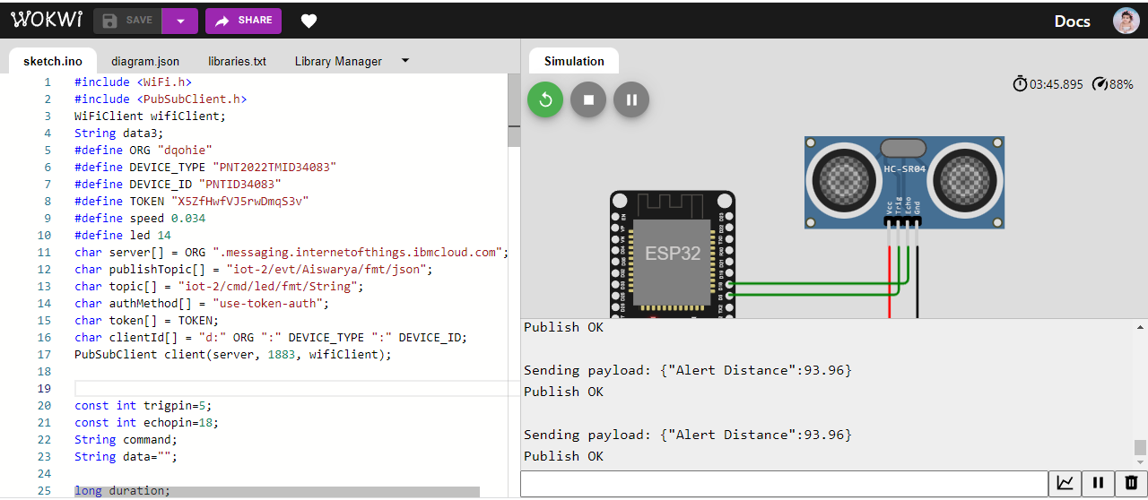

When distance<100:

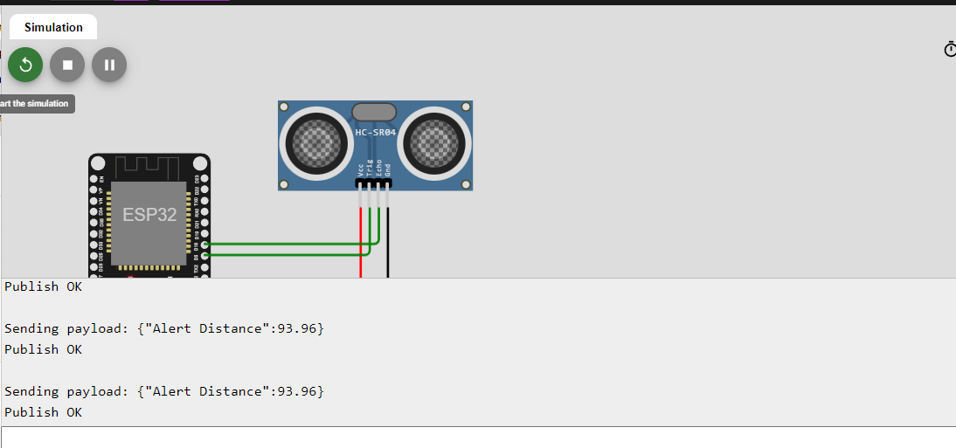

When distance>100:

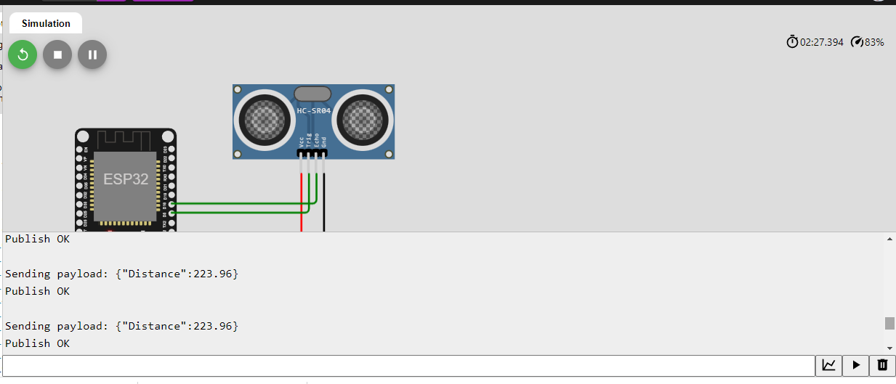

**IBM CLOUD OUTPUT**

